38.35: An electron’s energy after being accelerated by a voltage V is just 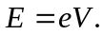 The most energetic photon able to be produced by the electron is just: 